**OS Security**

**Assignment 1:**

Assignment report for creating two Linux user accounts and setting file permissions so that only one user can read and write to a file, while the other user has no access:

**Objective**

The objective of this assignment is to create two separate user accounts on a Linux system and configure a file with permissions allowing only one user to read and write to it, while explicitly denying any access to the other user.

**Environment**

Ubuntu 22.04 LTS running on a virtual or physical machine with root or sudo access.

**Procedure**

1. **Open a terminal with sudo privileges**
   * Access your Linux system and open a terminal.
   * Ensure you have administrative (sudo) rights to create users.
2. **Create the first user**
   * Run: **sudo adduser user1**
   * Follow the prompts to set a password and user details.
3. **Create the second user**
   * Run: **sudo adduser user2**
   * Similarly, set a password and complete the setup.
4. **Switch to user1**

Run: **su - user1**

* + Enter the password for user1 when prompted.

1. **Create a private file**
   * Run: echo 'This is a private file.' > /home/user1/private.txt
   * This creates a file in user1's home directory.
2. **Set file ownership**
   * Run: sudo chown user1:user1 /home/user1/private.txt
   * Ensures the file is owned by user1 and their primary group.
3. **Set restrictive permissions**
   * Run: chmod 600 /home/user1/private.txt
   * This allows only the owner (user1) to read and write the file.
4. **Verify the permissions**
   * Run: ls -l /home/user1/private.txt
   * You should see output like: *-rw------- 1 user1 user1 ...*
5. **Switch to user2**

Open a new terminal or log out and run: su - user2

* + Enter user2's password.

1. **Test access from user2**
   * Try: cat /home/user1/private.txt
   * This should fail with a permission denied error, confirming user2 has no access.
2. **Return to user1 to confirm access**
   * Switch back to user1 and verify they can still read and write the file.

This setup ensures that only user1 has read and write access, while user2 (and all others) are denied access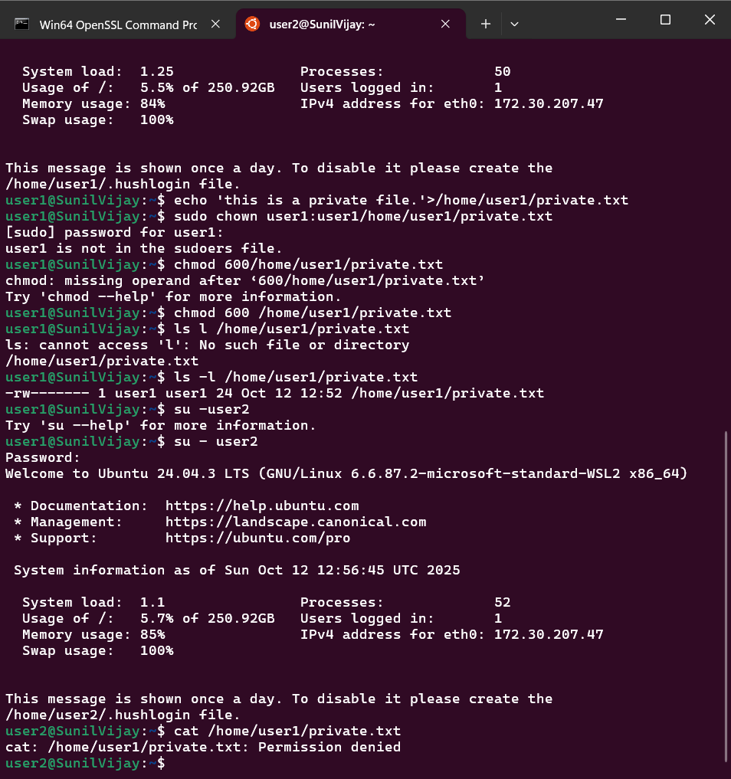

**Results**

* Two users successfully created (user1, user2).
* File exclusive_file.txt created with owner user1 and permission 600.
* user1 can read and write to the file.
* user2 is denied access, achieving the objective of exclusive access.

**Conclusion**

This assignment demonstrates Linux user and file permission management by enforcing strict access control on file resources. Using permission 600 effectively restricts the file to owner-only access, preventing unauthorized reading or modification by other users.

**Commands Summary**

| Command | Purpose |
| --- | --- |
| sudo adduser user1 | Create first user |
| sudo adduser user2 | Create second user |
| echo "text" > file as user1 | Create file owned by user1 |
| chmod 600 file | Set owner read-write, no access others |
| ls -l file | Check permissions and ownership |
| cat file as user2 | Confirm user2 access denial |